APQP4Wind requirements towards Suppliers and Sub-Suppliers

Dear Supplier,

As part of our effort to improve the quality of received materials and parts, and to reduce both your costs and ours, we have been working with APQP4Wind in order to achieve the quality threshold most industries achieve. For [insert your company name] to have a supply base that reaches the strategic goal of zero defects and minimized quality costs, the APQP4Wind methodology is a set of tools that will help achieve these strategic goals at [insert your company name] and likewise at your site. This initiative is designed to provide greater visibility, accessibility, and efficiencies in the way we need to work in the future.

This letter is addressed to our Suppliers in order to set our APQP4Wind requirements. We see APQP4Wind as an investment in quality that will pay off for us as Manufacturers and for you as a Supplier. We will start by focusing on our strategic Suppliers and/or Suppliers delivering high or medium-risk components.

Why requirements of APQP4Wind
The background for APQP4Wind is the continuous quality improvement that is needed to keep pace with the ongoing trend toward decreases in the Levelized Cost of Energy within the wind industry.

APQP is a well-known concept within the automotive industry and has been the backbone for maturing quality performance at Manufacturers and Suppliers for decades. In the context of APQP4Wind, the concept of APQP is adapted to the business areas and special conditions differentiating wind from automotive.

APQP4Wind aims to make the process of product quality assurance demands (APQP) as well as the product release process (PPAP) as clear as possible.

The standards made available in APQP4Wind have been created to substitute company-specific procedures and set aligned methods and procedures for all Suppliers and Sub-Suppliers nationally and internationally. The APQP4Wind Manual and corresponding Workbook and Toolbox define the framework for quality requirements and provide recommended formats and templates. Templates utilized by [insert your company name] Supplier base must be as per the communicated format by [insert your company name / insert name of your contact person or department].

The key benefits for the wind industry of using the approach described in the APQP4Wind manual are:
- Preventive approach to quality.
- Shift from quality control to quality assurance.
- Enables maturing of the global Supplier base.
- Supports standardization and simplification of processes to reduce time to market and increase efficiency.
- Full end-to-end calibration of the use and meaning of the APQP4Wind vocabulary.
- Supports profitable growth.

The business value of APQP for Suppliers and Manufacturers is based on our ability to translate the APQP4Wind framework into value-creating initiatives based on knowledge and experience in the deployment of the methods defined by APQP4Wind. Therefore, the Manufacturers have made an agreement on the aligned requirements for how we see the deployment of minimum competencies present at the Suppliers with whom we do business. These requirements are listed in this maturity matrix:

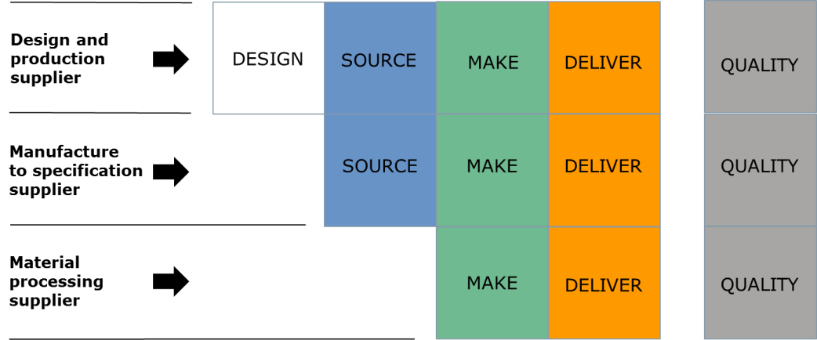
APQP4Wind maturity matrix

As regards the management level, the APQP4Wind Management Awareness Training will be requested in order to understand the concept and build the right team to meet APQP4Wind requirements.
As regards APQP4Wind specialists, there is a mix of experience and mandatory APQP4Wind training. The number of managers and specialists to be trained depends on whether the Supplier is within design and production, manufacture to specification, or material processing. The requirement is that all key functions within design, source, make, deliver and quality must be covered by certified managers and specialists in numbers related to current and future maturity. PPAP can only be signed by an employee who has attended APQP4Wind Specialist Training.

Mature Suppliers will provide increased competitiveness
APQP4Wind is now the common frame of reference to be used in the industry in order to strengthen the cooperation between Manufacturers and Suppliers and to ensure that parties on all levels communicate at eye level when it comes to quality assurance processes.

Training in the APQP4Wind concept is a vital part of establishing a common mindset and terminology in the wind industry when working with quality assurance processes. The APQP4Wind training concept is designed to build these competencies and mature the industry. The training concept has multiple advantages: It ensures that Suppliers follow the same procedures for the approval of sub-components (PPAP - Product Part Approval Process) and have the necessary understanding of how the standards are to be adopted in practice.

The official APQP4Wind training Suppliers are: Bureau Veritas Certification, DNV and TÜV Rheinland.

With this letter, [insert your company name] expects our Suppliers to start working with APQP4Wind as the joint framework for continuous quality improvement in addition to the current requirements [insert company name] has set forth with regards to qualifying materials.

We expect that you, as a Supplier to [insert your company name] and the wind industry, present a plan for the implementation of APQP4Wind in your company to us, including the completion of Management Awareness Training and Specialist Training.

How to get started
Start the process by visiting the website of APQP4Wind (www.apqp4wind.org) to read more about APQP4Wind, training possibilities and tools and sign up for a membership. We encourage you to become a member and support the initiative.

Best regards,

[insert your company name]
[insert name of your contact person]

